### **MOHAMED ZAHROUNI**

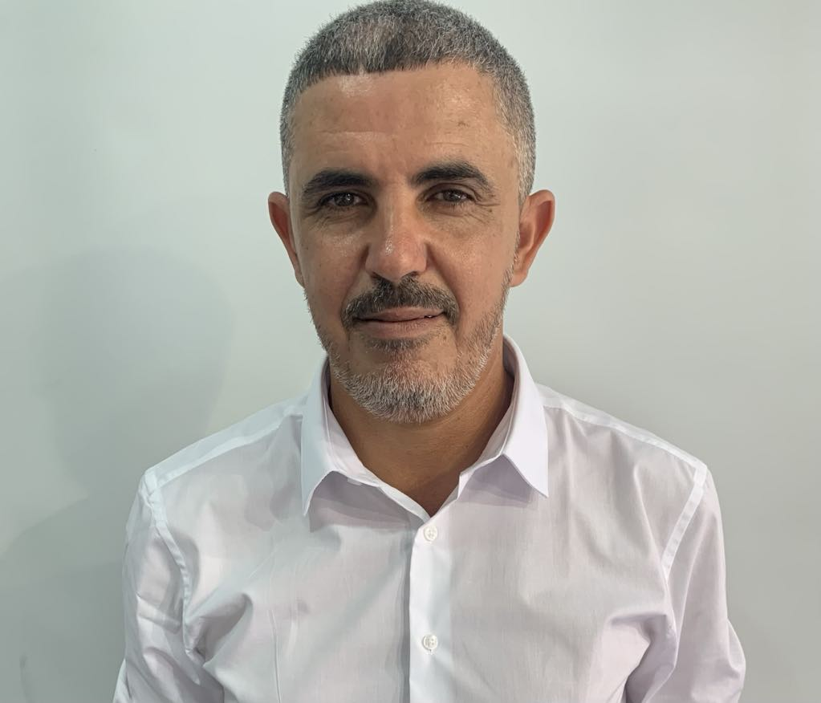

### **Full Stack JavaScript Developer** mohamedzahrouni@gmail.com­ | 00216 99 969 583 linkedin.com/in/mohamed-zahrouni | [github.com/mohamedzahrouni](https://github.com/MohamedZahrouni)

### www.linkedin.com/in/mohamed-zahrouni-773204117

### **Professional Summary**

I am a Full Stack Java Script Developer with a strong emphasis on solving complex problems and delivering scalable, high-quality software solutions. My expertise lies in creating intuitive, user-friendly interfaces and staying up-to-date with the latest technologies. I am committed to continuous improvement, innovation, and team collaboration.

### **SKILLS**

* **Front-End:** ReactJS, NextJS, React Native, HTML, CSS, TailwindCSS, Bootstrap
* **Back-End:** NodeJS, ExpressJS, Firebase
* **Design Tools:** Adobe Photoshop, Illustrator, XD, Figma
* **Databases:** MySQL, MongoDB
* **Soft Skills :** Communication, Scrum&Agile Methodologies, Public Speaking, Communication Skills, Critical Thinking

### ****EDUCATION****

**Master in Logistics**  
Düsseldorf University, Germany | 2009

**Master in International Business**  
Sfax Business School, Tunisia | 2005

**Baccalaureate in Experimental Science**  
20 Mars Secondary School, Sfax, Tunisia | 1999

### ****PROFESSIONAL EXPERIENCE****

**Production Logistics Manager, Rawassi Company**  
 Sfax, Tunisia | 2020 – 2023

* Collaborated with production planners to optimize schedules and oversee inventory management.
* Managed supply chain operations from procurement to delivery.

**Production Logistics Coordinator, Marquardt Tunesien**  
 Tunis, Tunisia | 2015 – 2019

* Managed logistics, coordinating with suppliers and customers, and controlled inventory levels.
* Utilized SAP ERP to update progress reports and manage production information.

**Storekeeper, MS Marketing Gmbh**  
 Köln, Germany | 2010 – 2014

* Oversaw logistics operations and trained teams in safety standards and company policies.

### ****Academic Projects****

**Kadamni - Mobile Application**  
SCRUM MASTER **|** July 2024

* **Description**: Led a team in developing a mobile app to streamline delivery operations, enhancing efficiency and ensuring seamless customer interactions.
* **Key features**: Implemented secure authentication, worker search, and an admin interface, using Scrum for efficient development.
* **Technologies Used**: ReactJS, TailwindCSS, MySQL, ExpressJS, Firebase, Cloudinary, EmailJS.

**Real-State -Web Application**  
DEVELOPER **|** July 2024

* **Description:** Developed a platform for buying, selling, and renting properties, integrating external APIs for enhanced user experience.
* **Key features:** Designed a user-friendly interface for property browsing and customizable profiles, implemented CRUD operations, responsive design, and animated transitions, while actively resolving issues for a seamless user experience.
* **Technologies Used:** NextJS, NodeJS, MongoDB, ExpressJS, Firebase, Cloudinary, RapidAPI, Redux.

**Best Shoes - Web Application**  
DEVELOPER | June 2024

* **Description:** Created an e-commerce platform for buying and selling shoes, enhancing product browsing with external APIs.
* **Key features:** Developed an intuitive UI, customizable profiles, and managed CRUD operations, ensuring a smooth E-Commerce experience by fixing bugs and integrating the contact form.
* **Technologies Used:** React, Next JS, Pure CSS, Tailwind CSS, Firebase, Cloudinary, JWT, Rest API.

### ****CERTIFICATIONS****

* **Full Stack JavaScript Web & Application Developer**  
  RebootKamp Sfax | 2024
* **DSH (Advanced German Language Proficiency)**  
  FH- Düsseldorf, Germany | 2008

### ****LANGUAGES****

* **German:** Fluent
* **English:** Intermediate
* **French:** Intermediate
* **Arabic:** Native

### ****INTERESTS****

Exploring new design trends and techniques, spending time with family, traveling to new places